Project Design Phase-II
Technology Stack (Architecture & Stack)

Date | 19-02-2026
Team ID | LTVIP2026TMIDS66350
Project Name | Calculating family expenses
Maximum Marks | 4 Marks

Technical Architecture:
The technical architecture of the Family Expense Management System is designed to provide a dynamic, real-time platform for recording, managing, and analyzing household expenses using the ServiceNow environment. The system allows family members to enter their daily expenses through a web-based interface, which is instantly stored in a centralized cloud database. Whenever a new expense is added, updated, or deleted, the system automatically recalculates totals and updates dashboards, ensuring real-time visibility of family spending. Business rules within ServiceNow aggregate daily expenses into overall family expense records, enabling accurate tracking by date, category, or family member. The platform also supports automated reporting, allowing users to view daily, weekly, or monthly summaries without manual calculations. Secure authentication ensures that only authorized users can access or modify financial data. This architecture enables seamless data flow from user input to storage, processing, and visualization, empowering families to monitor budgets effectively, identify spending patterns, and make informed financial decisions.
Example: When a family member records a grocery expense, the system immediately updates the total daily spending, monthly summary, and related reports, providing an up-to-date financial overview for the entire family.

Guidelines — Family Expense Management System
- Map out the logic for expense entry, aggregation, budgeting, and real-time updates of total family spending.
- Ensure the system supports multiple family members contributing expenses through a centralized interface.
- Use the ServiceNow platform as a cloud-based backend for secure data storage, processing, and remote access.
- Provide a user-friendly dashboard accessible via web browsers or mobile devices for viewing summaries and reports.
- Implement automated calculations to update daily, weekly, and monthly totals whenever new expenses are added.
- Include business rules to link daily expenses with overall family expense records and generate consolidated data.
- Identify storage for expense records, reports, and related data within the ServiceNow database.
- Enable reporting tools to produce financial summaries, charts, and insights for better decision-making.
- Ensure secure access control so only authorized family members can add, edit, or view sensitive financial data.
- If applicable, include features that analyze spending patterns and suggest budget adjustments or cost-saving opportunities.

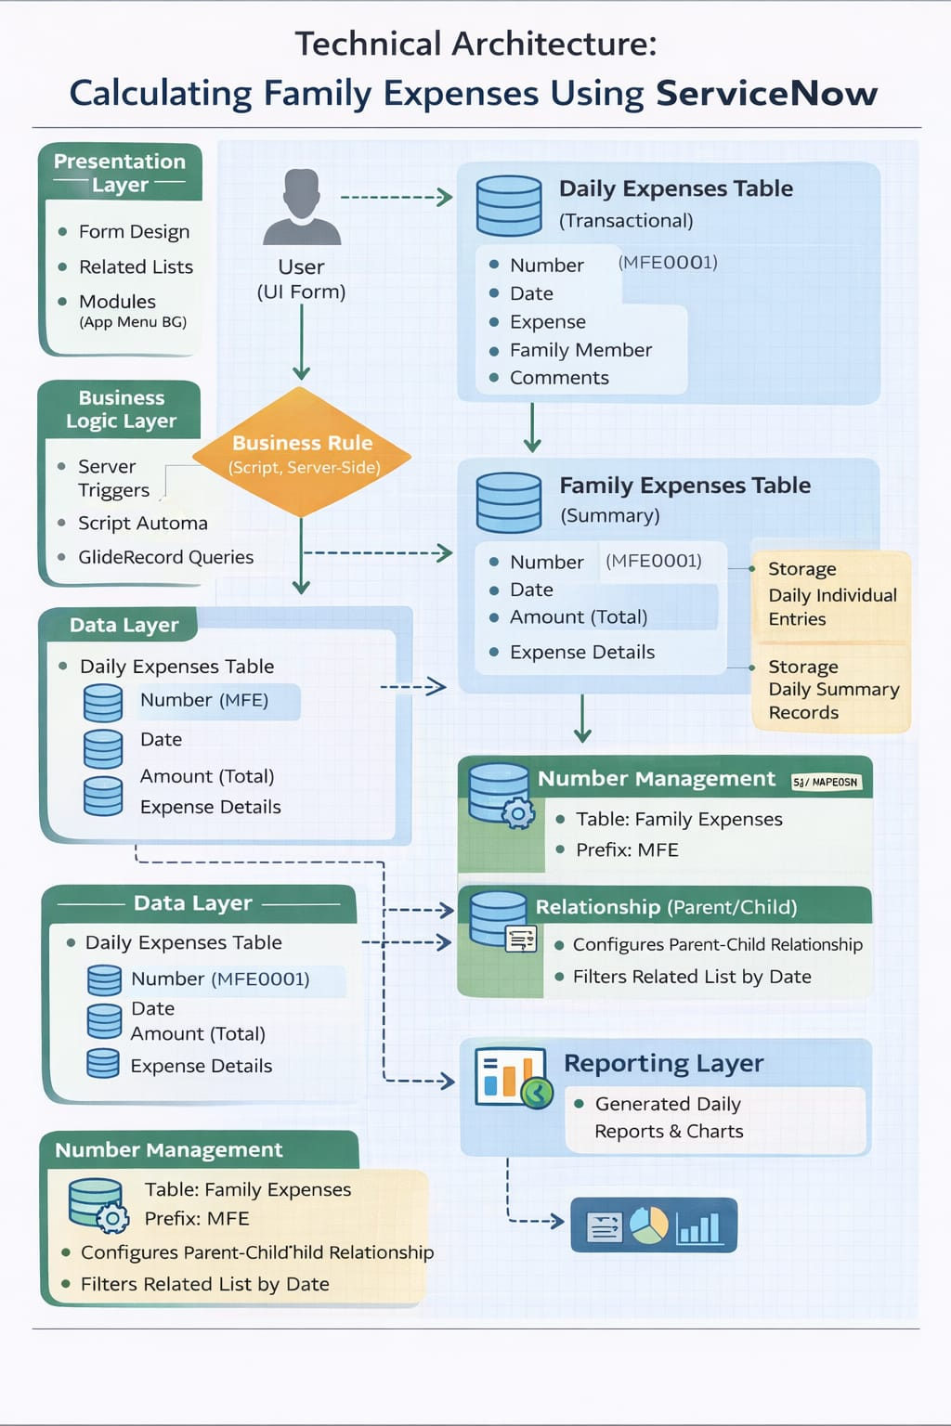
Table-1 : Components & Technologies:
S.No | Component | Description | Technology
1 | User Interface | Web-based interface for family members to enter expenses and a dashboard to view reports | ServiceNow Forms, Service Portal, HTML, CSS, JavaScript
2 | Application Logic-1 | Core logic for expense entry, validation, categorization, and updates | ServiceNow Business Rules, Client Scripts, Server Scripts
3 | Application Logic-2 | Real-time calculation service to update totals when expenses are added or modified | ServiceNow Glide APIs, Script Includes
4 | Application Logic-3 | Reporting and analytics service to generate summaries and insights | ServiceNow Reports, Performance Analytics
5 | Database | Stores expense records, family member details, categories, and reports | ServiceNow Tables (MySQL-based backend)
6 | Cloud Database | Remote storage ensuring centralized access from anywhere | ServiceNow Cloud Platform
7 | File Storage | Storage for attachments such as bills, receipts, or supporting documents | ServiceNow Attachment Storage
8 | External API-1 | Email or notification service for alerts when budget limits are exceeded | ServiceNow Notification Engine / Email Integration
9 | External API-2 | Integration with external financial tools if needed | REST APIs / Web Services
10 | Analytics Module | Provides insights into spending patterns and trends | ServiceNow Performance Analytics
11 | Infrastructure (Server / Cloud) | Hosting environment for application, database, and services | ServiceNow SaaS Cloud Infrastructure

Table-2: Application Characteristics:
S.No | Characteristics | Description | Technology
1 | Open-Source Frameworks | Frameworks used for customization and interface enhancement | ServiceNow Platform with HTML, CSS, JavaScript
2 | Security Implementations | Access control and protection of sensitive financial data | Role-Based Access Control (RBAC), Authentication, HTTPS/TLS
3 | Scalable Architecture | Ability to handle growing number of users and expense records | Cloud-based multi-tenant architecture (ServiceNow SaaS)
4 | Availability | Ensures system is accessible anytime for recording expenses | High-availability ServiceNow Cloud with backup and recovery
5 | Performance | Fast response for data entry, retrieval, and report generation | Optimized ServiceNow database, caching, efficient scripts

